Carin Gardner

WDD 130

Week 03 – WWR plan

I chose the following logo for my whitewater rafting site:

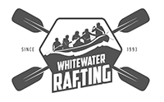

I chose the following color scheme for my site:

Primary – 618985

Secondary – F2E3BC

Accent_1 – 414535

Accent_2 – C19875

For typography I chose the following fonts:

Headings – Permanent Marker

Text – Afacad Flux

The color palette I selected can be found at:

https://coolors.co/palette/96bbbb-618985-414535-f2e3bc-c19875